HW5

by 20171645

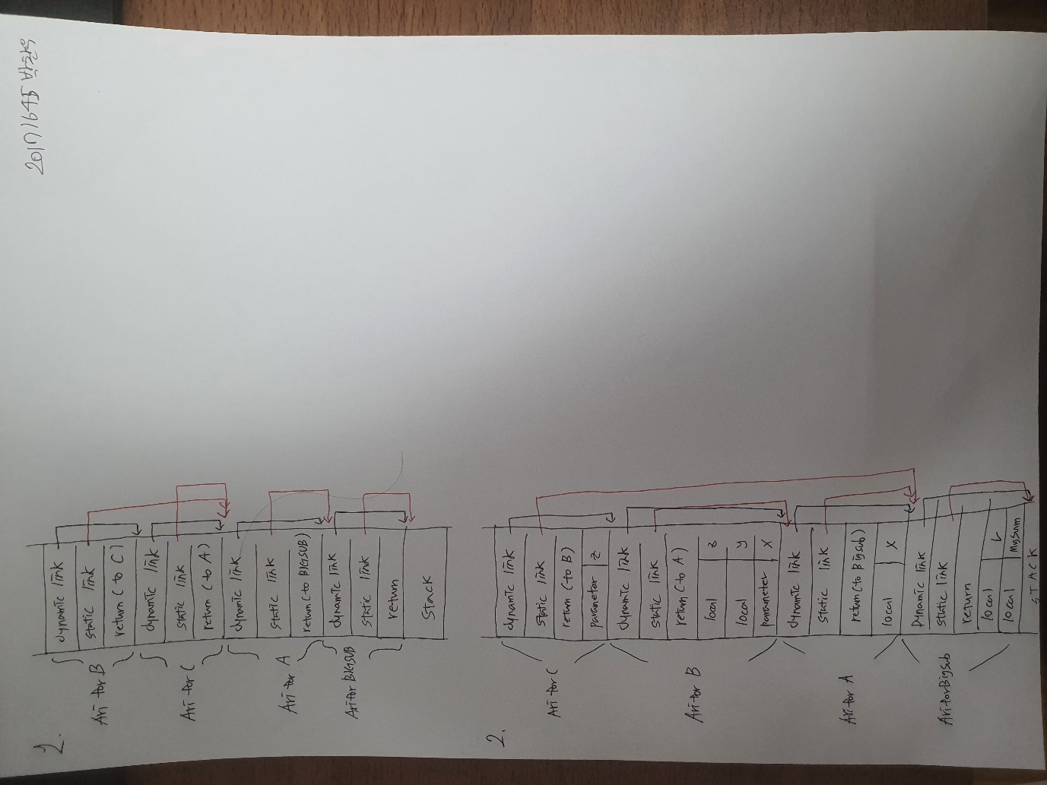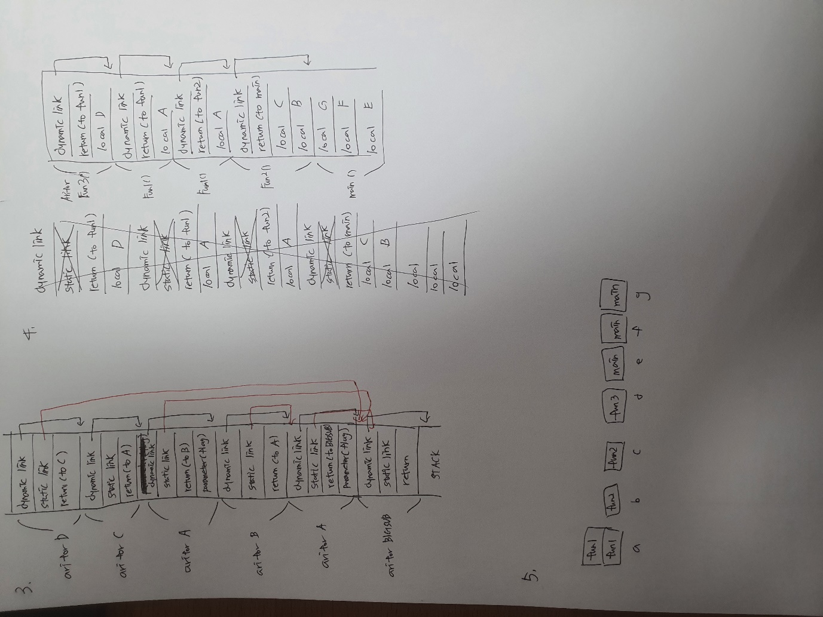

6. If local variable is declared as static. Static modifier makes variable history-sensitive.